**Recycled Gadgets: How to Go Green**

With the fast advancement of technology, we must be more aware than ever of how we dispose of electronics when they reach their end-of-life.

Of course, we all want to get our hands on the most up-to-date televisions, computers, headphones, and other cutting-edge technology. But what do you do if your laptop starts to slow down, your speakers aren't loud enough, or your old phone starts to malfunction now and then? The solution is far more straightforward than you would imagine.

We've whittled down all of the eco-friendly options and statistics to assist you in going green with your discarded electronics. We'll also look at how poor e-cycling practises are contributing to an alarming rate of electronic trash in this blog.

**The Greening Effect**

Did you know that every year, 50 million tonnes of electrical equipment are discarded all across the world? As a result, recycling obsolete electronics has become a top issue for both consumers and corporations.

You might not realise how much energy your electronics consume just by looking at them. Take a comprehensive tally of your device usage when you get the opportunity. Nintendo DS and Play Stations, iPhones and iPods, TVs, and computer monitors are all examples of electronic devices. When you consider all of the items that a person utilises on a daily basis, the magnitude of the influence we're having becomes clear.

Because worldwide e-waste growth is outpacing global recycling efforts, it is critical to generate, use, and dispose of electronic trash in a sustainable manner.

**Why is there such a push to become green?**

Mercury, lithium, copper, palladium, led, cobalt, and other elements are used in many electronic devices. These compounds are in scarce supply, yet they are extremely important in today's products, thus they should not be discarded. More significantly, these chemical components pose a risk to our ecosystem and may cause harm if they leak into the soil, air, or water.

Instead of decomposing in a landfill, old computers, office equipment, televisions, and other everyday devices serve a better purpose. Consider recycled electronics as a commodity and potential money source.

The proper disposal of electronic trash is the key to success. Businesses may collaborate with computer disposal and e-cycling programmes like ecogreen, which provide drop-off and pickup services for end-of-life gadgets.

**Go Green by Following these gadget tips:**

**Buy Used:**

By purchasing pre-owned green devices, you are not only prolonging the life of the electrical item, but you are also reducing your carbon footprint and saving a lot of money. Because manufacturers produce new devices at an exponential rate, getting the latest technology at a reasonable price might be a simple endeavour.

**Buy Green Gadgets Made from Recycled Materials**

Make sure you know what materials are utilised in the items or gadgets you're looking for. Choose recycled green devices made of low-impact materials and obtained in a sustainable manner. We realise that finding green devices that are made in a sustainable manner is difficult, but not impossible. Even if your equipment isn't manufactured from recycled materials, be sure it's recyclable.

**How to Use Renewable Energy to Go Green**

Going green does not need the installation of solar panels on your property. Small charging systems that use solar/wind energy to power gadgets are already readily available. These green charging techniques absorb energy throughout the day, allowing you to recharge your devices at night or the next day.

**Utilize All of a Gadget's Features**

Most devices are multipurpose, and utilising all of their capabilities is the greatest approach to reduce their consumption. In exchange, you're getting the most out of the device by focusing on the "essentials" and eliminating the "non-essentials" from your daily routine. Electronic cleaning also reduces the amount of things you need to charge on a daily basis. Alarm clocks, voice recorders, notepads, cameras, and music players are just a few examples of "must have it" devices. As a result, your phone deleted some of the existing devices that you were previously relied on.

**Make Use of Gadgets for a Longer Time**

Because technology advances so rapidly, you may not be able to get enough usage out of them before they need to be replaced. When it comes to mobile phones, gaming devices, and other comparable technologies, this assertion is correct. We realise that it's tempting to upgrade your phone with your contract renewal, or to upgrade your laptop when a new version is out. But before you do, ask yourself, "Do I really need it?" and weigh the benefits and drawbacks of replacing your old hardware.

**Old Gadgets Can Be Recycled!**

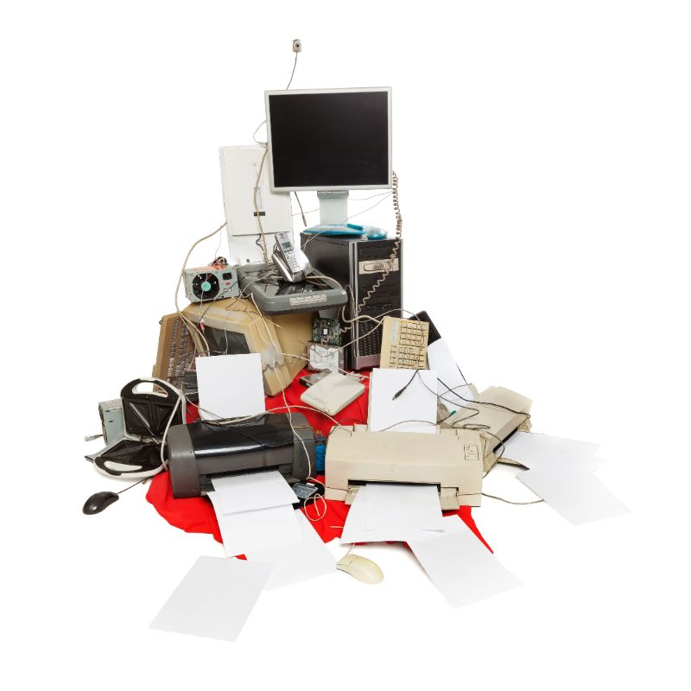

You surely don't want to throw away a device that has reached the end of its useful life. Use one of the rising number of free recycling programmes to avoid harmful e-waste. Many manufacturers will gladly accept old equipment for free, making disposal simple for both you and the environment. In Bristol, look for nearby recycling facilities or other free recycling services. However, be certain that you're sending your devices to an environmentally responsible recycler, one that claims to reduce electronic waste sanitation and follows UK regulations.

**Reduce your electronic carbon footprint**

Even if you follow all of the above suggestions, your device is likely to leave a carbon imprint. Carbon offsets can be purchased online to help counteract this. Your contribution goes directly to carbon-reduction efforts. Some manufacturers make it simple for customers by allowing them to purchase carbon offsets at the same time as purchasing their new product.

If you have any queries concerning Recycle Pro's recycling programmes, please contact us at info@recyclepro.co.uk or call us at [+441213822532](tel:+441213822532).